**------- git author reset ---------**

**STEP 1**

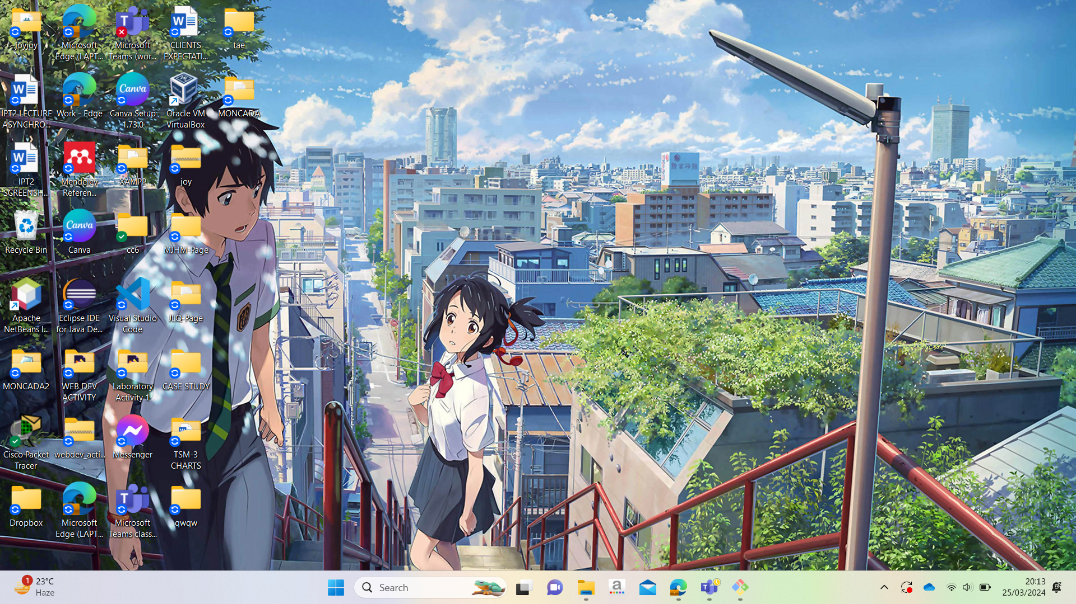

**STEP 2**

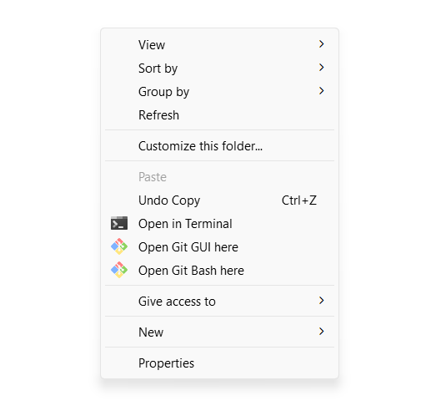

**STEP 3**

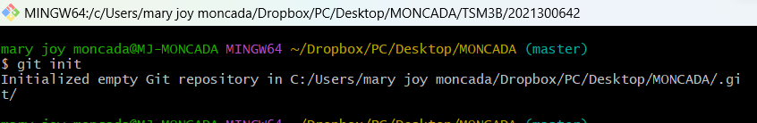

**STEP 4**

**STEP 5**



**STEP 6**

**STEP 7**

**-------- connecting from git to GitHub -------**

**STEP 8**

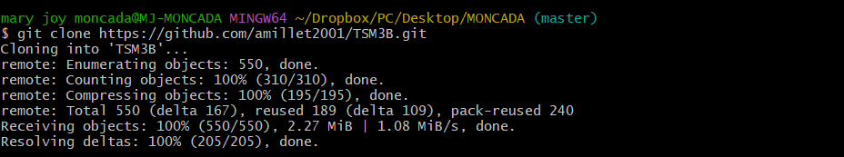

**STEP 9**



**STEP 10**



**STEP 11**



**STEP 12**



**STEP 13**

**STEP 14**

**STEP 15**

**After using the command git push -u origin moncada-late-act2, windows will pop up then it will prompt you to sign in your git hub account to authorize you to access the GitHub Repository.**

**After successfully accessing the GitHub Repository, go inside your branch and folder name (git)**

**STEP 16**

**----------- creating virtual machine -----------**

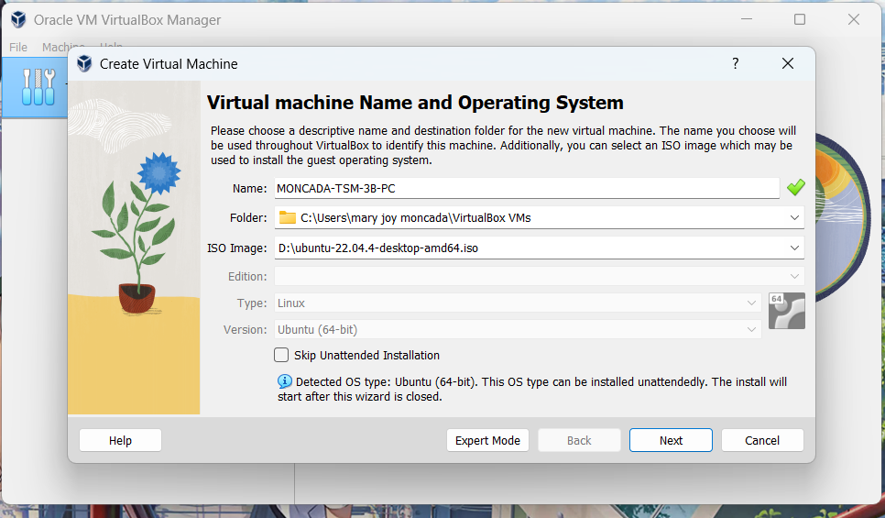

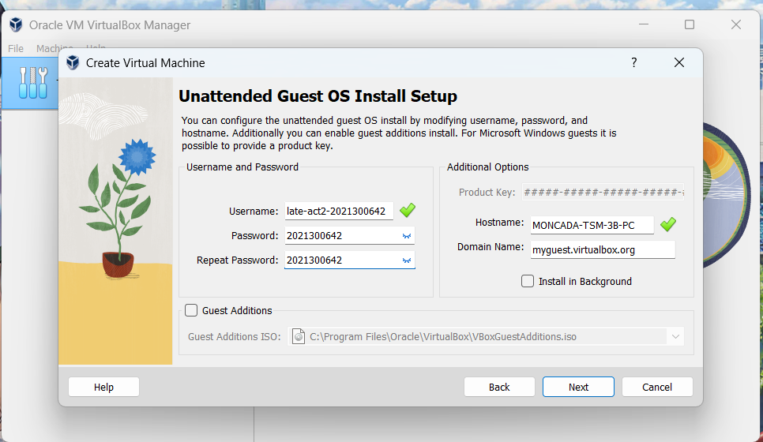

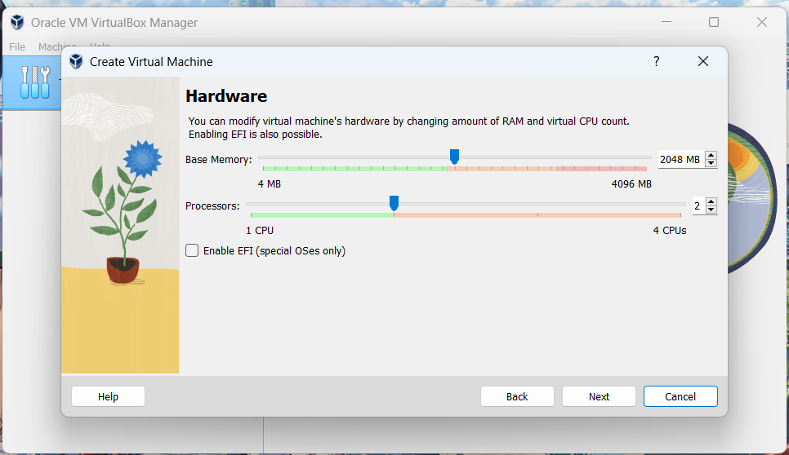

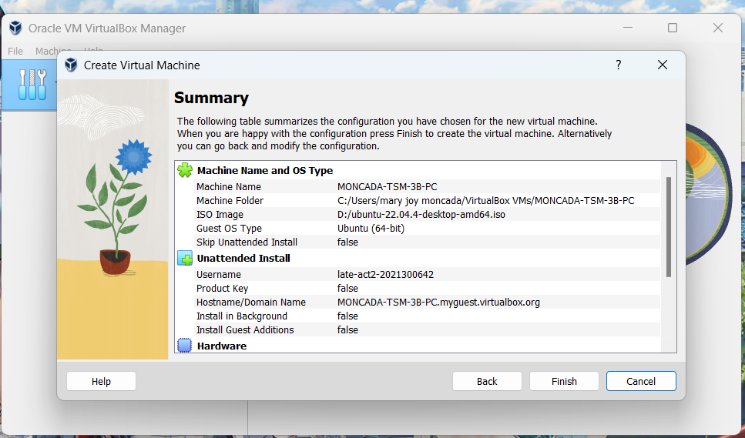

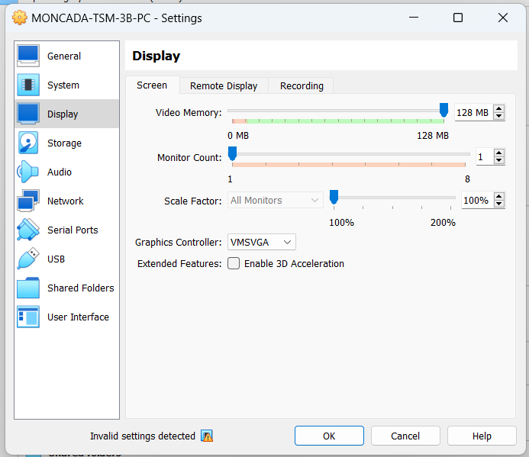

**STEP 17**

**STEP 18**

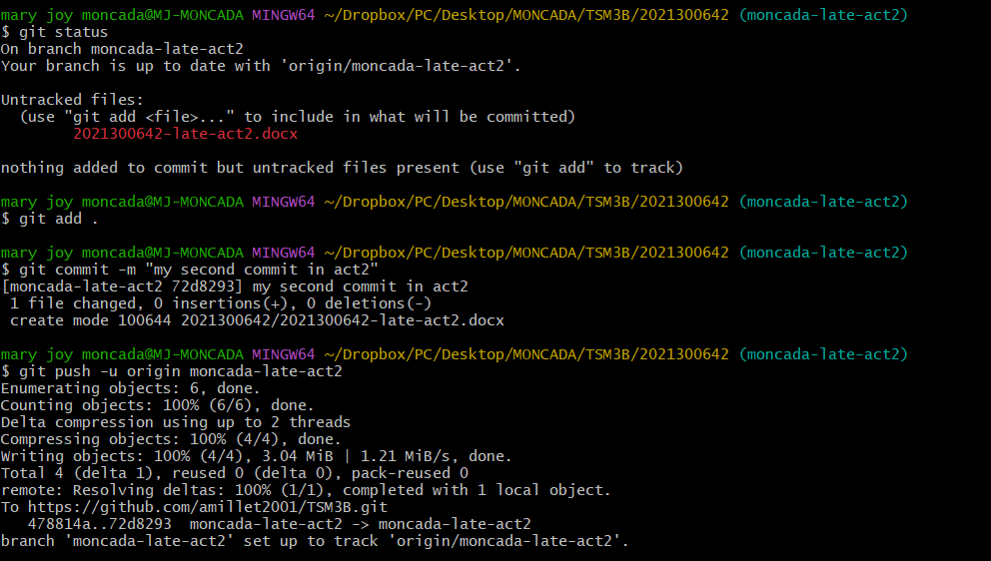

**STEP 19**

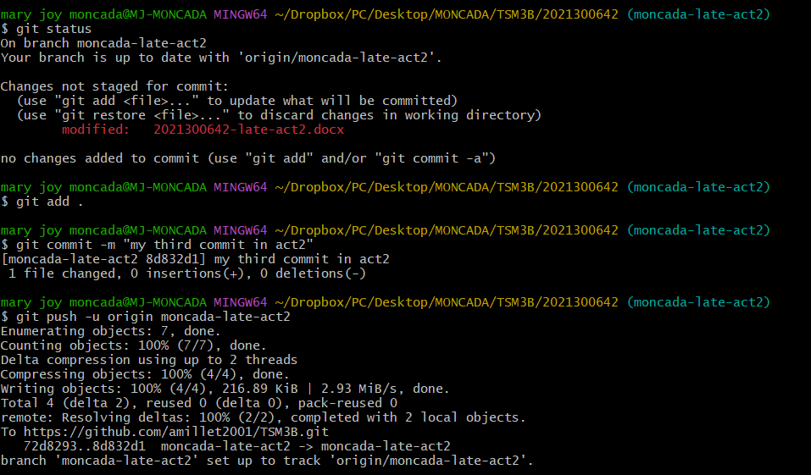

**STEP 20**

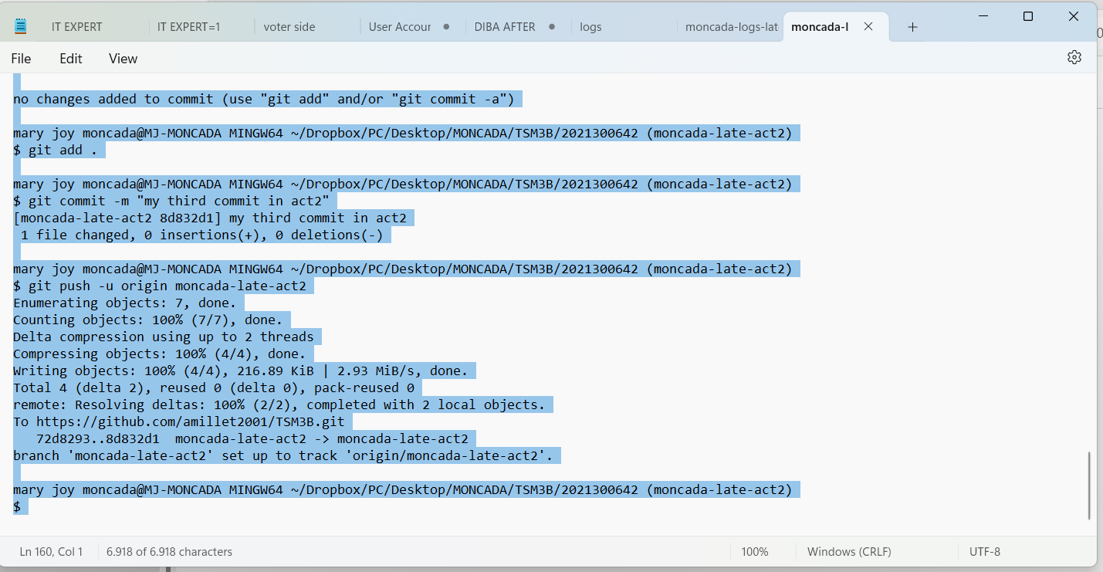

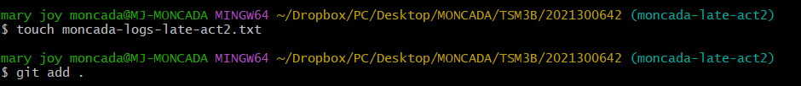

**STEP 21**

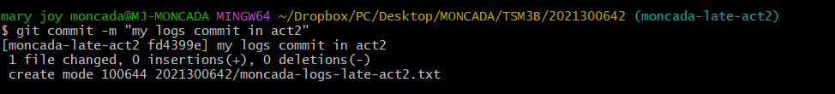

**STEP 22**

